Goal Setting Toolkit
The kit includes nine different cards for different goal setting needs. You may find that you use many of them or find one particular one that you print over and over. Here is a highlight of some of the cards and common uses for them.
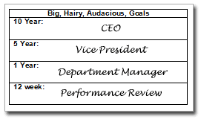
The BHAG card. This card is useful for planning your long term goals. With a line for 10 year, 5 year, and one year goals, you’ll find this card is a great starting point for goal setting. Write down a few words that describe where you want to be at each milestone. Take a look at the example card to the left for ideas. The key here is to think and dream BIG! When you can picture where you want to be a few years out it will help you solidify your shorter term goals.

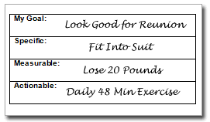
The My Goal Card: This universal goal setting card will help you remember that most goals need to be specific, measurable, and actionable. To use this card, write down a title for the goal and then write down the specifics. Focusing on the three areas on the card will help you create a goal that is easily accomplished.

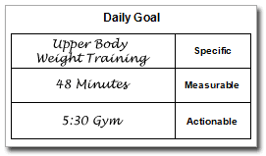
The Daily Goal Card: Once you have the other goal cards completed the daily goal card is an easy reminder of what needs to be done TODAY. This is a great card to keep with you at all times. Put it on your desk where you can see it. Take it with you in the car. If you see it… you will remember it! This is a great card to print multiple copies of.

Setting Performance Goals: When you have goals such as weight loss that have measurable milestones we have a couple of cards that will help you track your progress. Included are a generic item-results card and a 12 week Goal-Actual card. Also included is the 4 week milestone card along with a weekly reminder and weekly milestone card.
The 48 Minute Card: This card is helpful when used with a 48 minute focused work session. The card is divided into 12 minute sections and is a quick and useful way to plan out a focused work period. Fill in this card before working to help you stay focused for all 48 minutes.
These cards fit easily in pocket or purse and are a great addition to our Walleteer organizer. Download a set today and make sure your new goals are written down and put where you can see them.

Goal Setting  Toolkit
  Four Week Milestones
  Week 1:
  Week 2:
  Week 3:
  Week 4:
  Weekly Reminders
  Mon
  Tues
  Wed
  Thurs
  Fri
  Sat
  Sun
  Big, Hairy, Audacious, Goals
  10 Year:
  5 Year:
  1 Year:
  12 week:
  Weekly Milestones
  Mon
  Tues
  Wed
  Thurs
  Fri
  Sat
  Sun
  My Goal:
  Specific:
  Measurable:
  Actionable:
Daily Goal
  Specific
  Measurable
  Actionable
  Actual
  Goal
  Week |  |  |  |  |  |  |  |  |  |  |  |  | Goal
  48 Minutes
  12:
  24:
  36:
  48:
  Results
  Item |  |  |  |  |  |  |  |  |  |  |  |  |  |  | Total

